1. Navigate to the Hernando County Skyward Student site and enter your Username and Password:
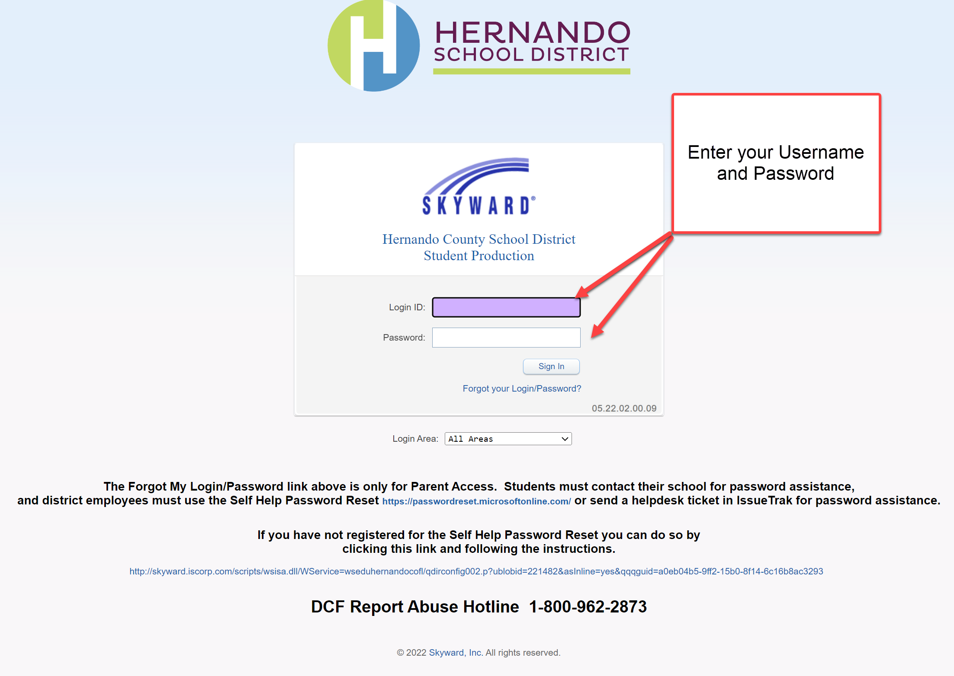
2. On the Home Screen please click on the “District Links” icon
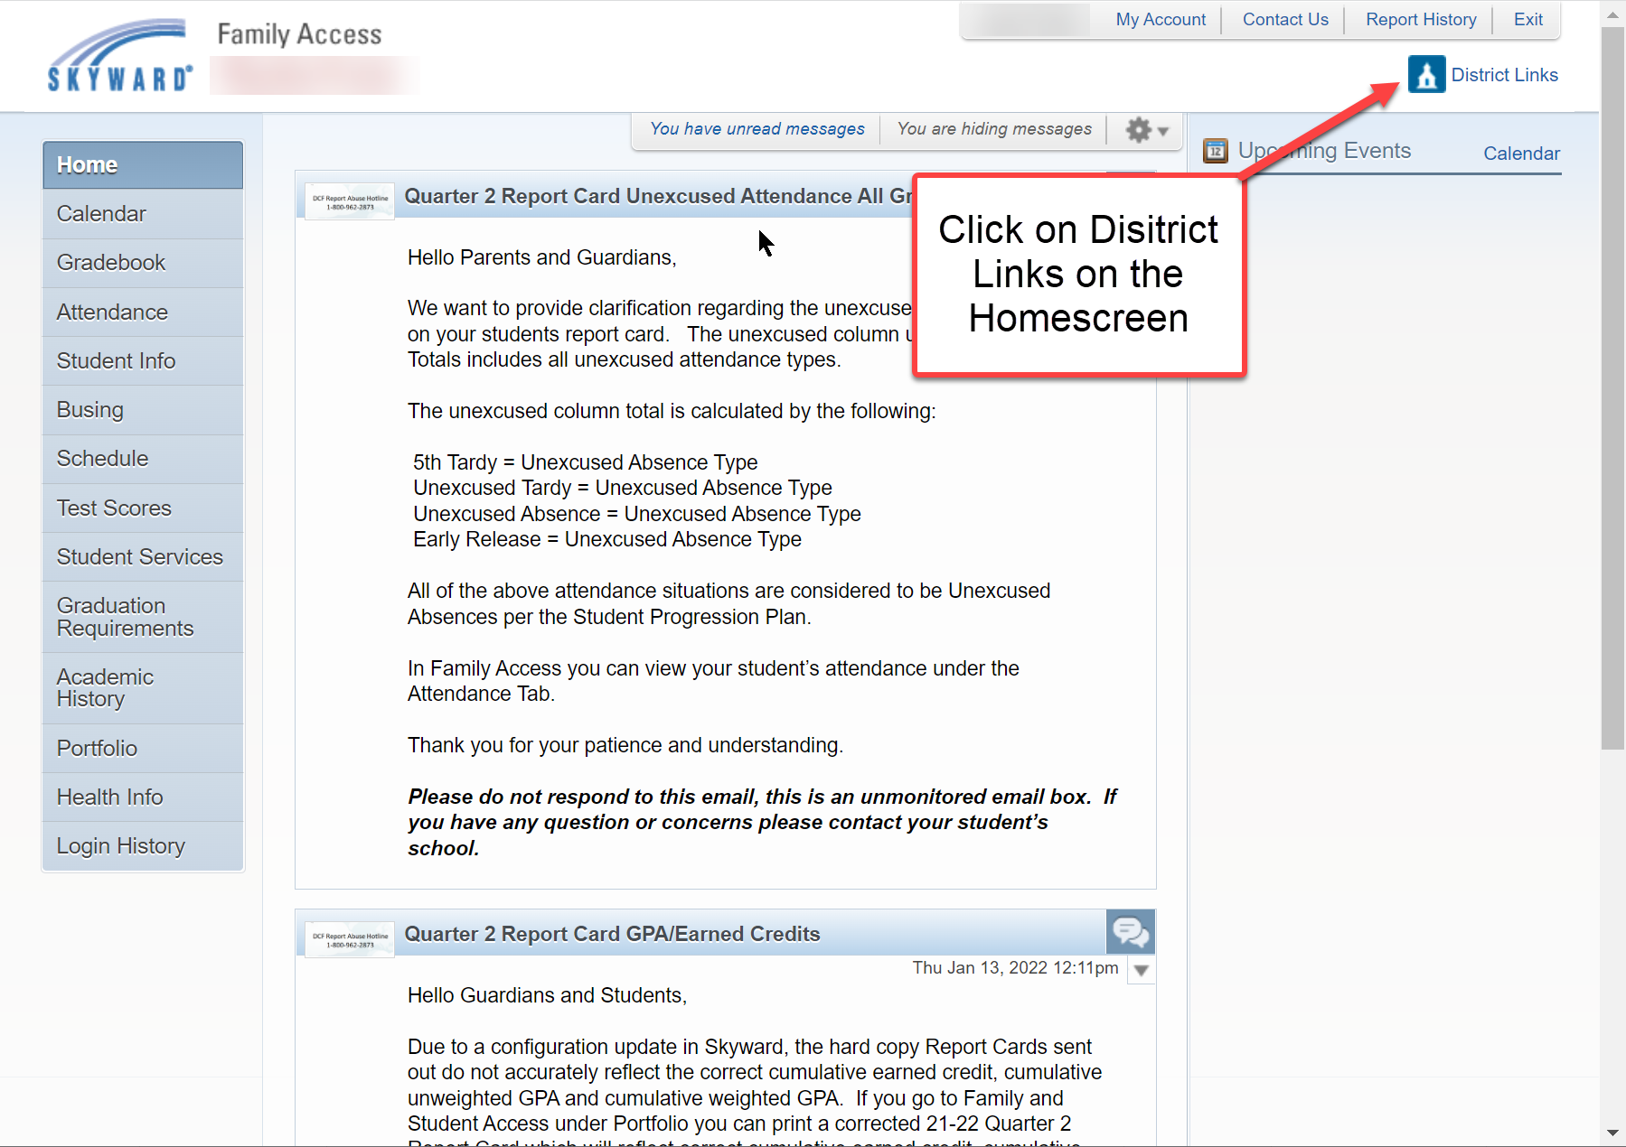
3. Click on “State Assessments” Link
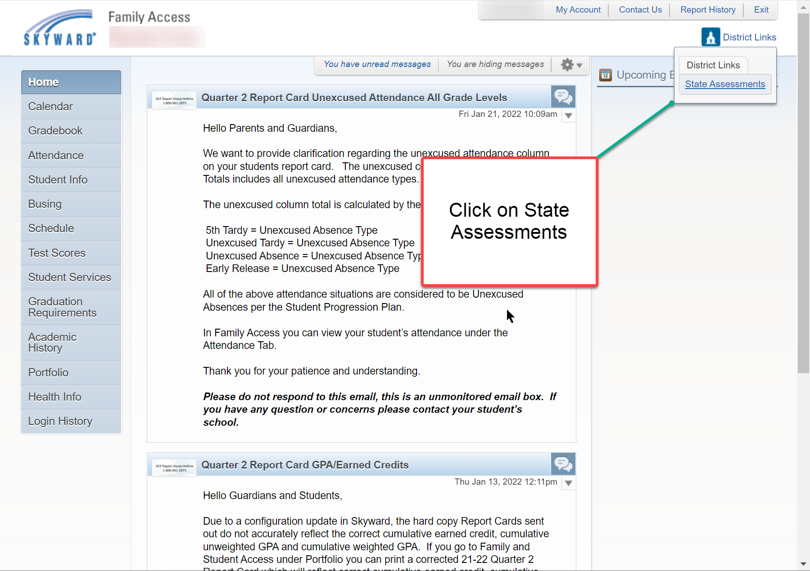
4. You will be taken to the State Assessments system and automatically logged in so you may see your student’s data and reports:
